Insights for Recommendation Systems in E-Commerce Using Segmentation and Regression

Team 2
DS515_01_ON: Data Science Overview – USADL – Summer 2024-2025
School of Technology and Computing
City University of Seattle
KhanHumairaAkram@cityuniversity.edu, MBA-TM
JanMcConnell@CityUniversity.edu, MSDS
MirayRosalia@cityuniversity.edu, MSDS

Abstract

This project aims to analyze the current state and forecast future trends in customer sales for the most popular groupings based on current sales and transactions using R programming. We will utilize segmentation techniques, such as K-means and agglomerative clustering, to provide customer segment profiles that can be utilized by collaborative filtering to improve recommendations. We will also identify opportunities using descriptive and predictive analytics techniques and methods, including regression and time-series analysis, and visualizations using ggplot2.

Keywords: recommendation system, segmentation, k-means, agglomerative clustering, collaborative filtering

1. INTRODUCTION

In the fast-paced fashion industry, where consumer preferences and market trends evolve rapidly, staying ahead of customer demands is paramount. For a global fashion leader like H&M, leveraging advanced data analytics to understand and anticipate these shifts is crucial for maintaining competitive advantage. This project aims to analyse the current state and forecast future trends in customer sales, focusing on the most popular product groupings. By employing sophisticated R programming techniques, including segmentation methods such as K-means and agglomerative clustering, we will create detailed customer segment profiles. These profiles will serve as the foundation for enhancing H&M's recommendation system through collaborative filtering, thereby improving personalized product recommendations. Moreover, we will identify key opportunities using descriptive and predictive analytics methods, including regression and time-series analysis, to provide actionable insights. Visualizations created with tools like ggplot2 will aid in interpreting the data, ensuring that our findings are both comprehensive and accessible. Through this analysis, we seek to equip H&M with the insights necessary to refine its marketing strategies, optimize inventory management, and ultimately deliver a more personalized shopping experience to its customers.

2. DATA COLLECTION

The data collection phase focused on acquiring a comprehensive dataset that would serve as the foundation for developing our recommendations. We sourced the fashion dataset from a well-established online repository, ensuring it contained a rich set of attributes relevant to our analysis (Kaggle, 2024). The dataset consists of three separate .csv files, and includes information on over 100,000 articles of clothing, over a million customers, and millions of transactions, encompassing attributes such as product codes, names, types, groupings, graphical appearances, color groups, and detailed descriptions. Each attribute provides valuable insights into the characteristics of the products, which are crucial for both collaborative filtering and segmentation techniques. By obtaining data with such depth and variety, we ensure that our recommendation system can leverage a broad spectrum of information for which to generate accurate and personalized recommendations for new customers. This thorough data collection process lays the groundwork for a robust and effective analysis, enabling us to extract meaningful patterns and deliver valuable insights.

The files included in this dataset are:
- articles.csv (‘articles’)
- customers.csv (‘customers’)
- transactions train.csv (‘transactions’)

3. PREPROCESSING

We performed initial observations to understand the structure and contents of each .csv file in the dataset. This included checking for missing values, generating summary statistics, and examining the first few rows to get a sense of the data's composition. We then conducted basic data cleaning to trim leading and trailing spaces from column names, manage missing and “NA” values, and remove duplicate rows to ensure the integrity and quality of our datasets. DataFrames were created as they are the most common and convenient data structures for handling tabular data in R, enabling subsequent analysis.

Summary Statistics
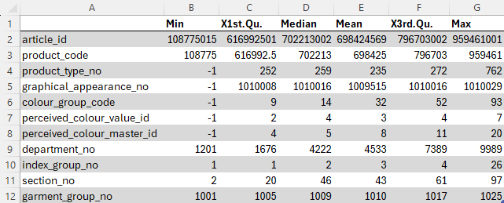
Figure 1: Summary of ‘articles’ Dataset
In the ‘articles’ dataset, the ‘article_id’ and ‘product_code’ variables show a wide range of values, indicating a large number of unique articles. The ‘product_type_no’ and ‘graphical_appearance_no’ variables also have a broad range, which might indicate a diverse set of products and appearances.

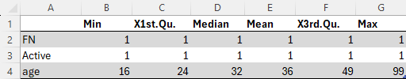
Figure 2: Summary of ‘customers’ Dataset
In the ‘customers’ dataset, the ‘age’ variable shows a reasonable distribution of ages, with a mean age of around 31 years. The ‘FN’ and ‘Active’ variables indicate the presence of flags or indicators, where most values are 0 or 1.

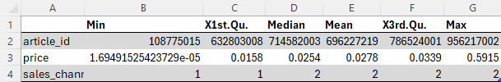
Figure 3: Summary of ‘transactions’ Dataset
In the ‘transactions’ dataset, the ‘price’ variable shows a wide range, with most transactions having prices concentrated around the mean of approximately 0.028, which is a normalized value rather than a direct dollar amount for analysis purposes. The ‘sales_channel_id’ variable indicates that transactions occur through two main channels, but there is no indication if that means online versus in-store purchases.

Data Cleaning and Preparation
- Missing values in numeric columns in the ‘articles’ and ‘transactions’ datasets were filled with the median value of the respective column, ensuring that the dataset remains usable by filling gaps with a statically reasonable value, maintaining the overall distribution.
- Duplicate rows were removed from the ‘articles’ and ‘transactions’ datasets, ensuring that each entry in the datasets is unique, which is critical for accurate analysis and modeling.
- For the ‘transactions’ dataset, the ‘t_dat” column was converted to a date type, which is essential for performing accurate operations and analysis for time-based calculations.
- For the ‘customers’ dataset, any customer missing ‘age’ were removed rather than replacing missing values with the median. This decision was made to maintain the integrity of the dataset by avoiding the introduction of potentially misleading information. While replacing missing values with the median is the common approach, it assumes that the missing data is randomly distributed and that the median value is representative of the missing values. If the missing data is not random or if the age variable has significant importance, imputing it with the median could lead to biased results, and by removing these records, we ensure that our analysis is based only on complete and accurate data, which is more appropriate for our specific objectives.

After data cleaning, the datasets were explored again to ensure that the cleaning process was successful to provide a solid foundation for further analysis and modeling.

Normalization
Normalization is a preprocessing technique used to scale the values of a variable, so they fall within a specific range, typically [0, 1] or [-1, 1]. This process is often used to ensure that different variables contribute equally to the analysis or model, particularly in algorithms that are sensitive to the scale of input data, such as regression or clustering.

We discovered that the ‘price’ variable in the ‘transactions’ dataset had already been normalized, rendering this preprocessing step unnecessary as any further normalization could distort the data, especially if the original normalization were done using a different method or scale, which can lead to misleading interpretations or incorrect conclusions.

Outliers
Outliers may represent significant (e.g., rare, extreme) events that are important for analysis. Removing them could result in the loss of relevant information that may lead to incorrect conclusions or recommendations. In some cases, outliers may not be errors, but rather valid data points that reflect natural variability in the dataset. To provide a comprehensive analysis without introducing bias by selectively removing data, no outliers were removed from the ‘articles’ or ‘transactions’ datasets to preserve all data points and to ensure the integrity and completeness of the dataset. The ‘transactions’ dataset had already been normalized, which standardized the data and minimized the presence of extreme outliers.

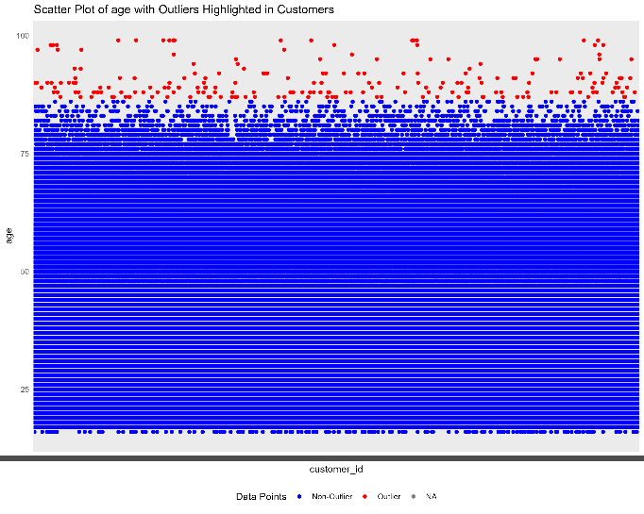
Figure 4: Outliers in ‘customers’ dataset
This scatter plot is a visual representation of the ‘customers’ dataset, focusing on the ‘age’ column (y-axis) and differentiates between data points that fall within the defined range (blue; age < 90) as defined by the 1st and 99th percentiles, and the outliers (red), which are the data points that fall outside of the define range, primarily with age > 89. This plot helps to visually confirm that the process of outlier detection and capping was successful, and it provides a clear distinction between the data points that were modified and those that were not.

4. VISUALIZATIONS AND ANALYSIS

The analysis and visualizations were completed using the following R libraries/packages (R Core Team, n.d.):

- caret: for building, tuning, and comparing predictive models.
- cowplot: a set of functions to combine multiple ‘ggplot2’ plots to facilitate creation of complex plot arrangements, aligning multiple plots into a single grid.
- cluster: provides functions for cluster analysis, including hierarchical and non-hierarchical methods, helping to identify clusters in data where observations within the same group are more similar to each other than to those in other groups.
- dyplr: used for data manipulation, providing a set of functions that help to easily manipulate DataFrames by performing operations such as filtering rows, selecting columns, reordering, summarizing, and joining DataFrames.
- e1071: contains functions for machine learning and statistical modeling, including functions for Naïve Bayes, clustering, etc.
- factoextra: a very feature-rich library used to visualize the outputs of multivariate data analyses, including cluster analysis, principal component analysis (PCA), and correspondence analysis, providing easy-to-use functions for extracting and visualizing information from various clustering and dimension reduction techniques.
- ggplot2: used for the creation of complex and customizable plots using a layered approach.
- lubridate: used for working with dates, including date arithmetic.
- RColorBrewer: provides color schemes for improving data visualization, and includes schemes designed to be colorblind-friendly.
- readr: used for reading data into R, particularly from .csv files and other delimited formats, providing functions that are faster and more efficient than the base R equivalents.
- SnowballC: used for word stemming to aid in text analysis and text mining.
- summarytools: tools for creating detailed summaries, frequency tables, and descriptive statistics for data frames and vectors.
- tidyr: helps create tidy data, where each variable is in its own column and each observation in its own row.
- tm: provides functions for text preprocessing, such as stemming, removing stop words, etc.
- wordcloud: creates word clouds to visualize the frequency of words in a text corpus, with the most frequent words displayed larger than words less frequent.

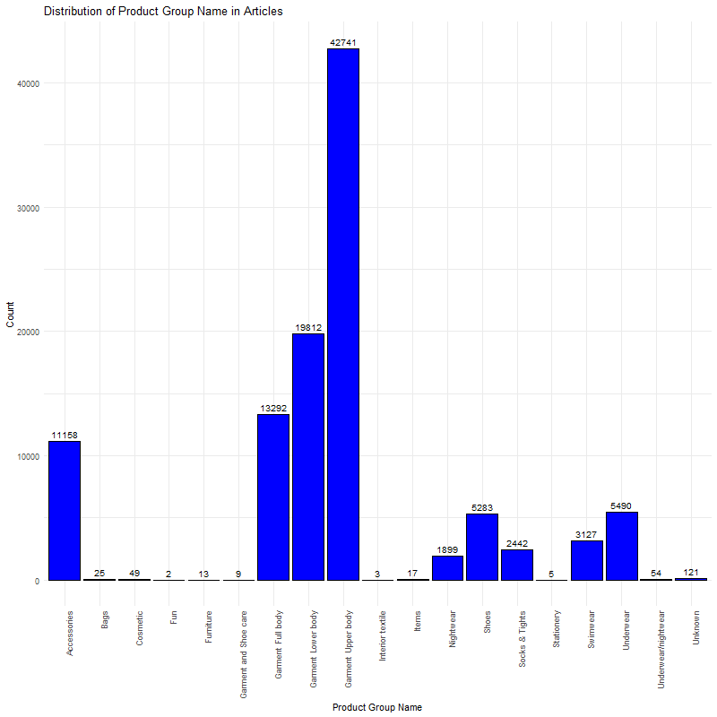
Figure 5: Distribution of Product Group in ‘articles’
This plot represents the distribution of different product groups in the ‘articles’ dataset. Each bar corresponds to a distinct product group name, and the height of the bar indicates the count of articles belonging to that group. The distribution is highly skewed, with a few product groups having an extremely high count, while many others have relatively low counts, which suggests that the dataset is dominated by a few product categories, particularly upper and lower body garments.

Focusing on the ‘Garment Upper body’ product group, we examined attributes such as color, graphical appearance, department, and other relevant characteristics within this product group.

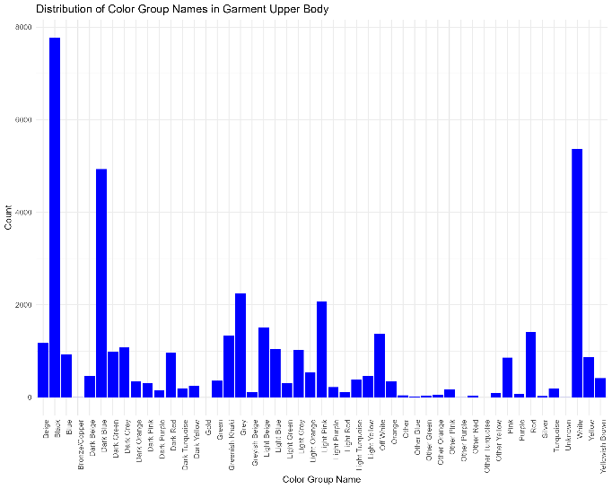
Figure 6: Distribution of Color Group Names in ‘articles’
This bar chart plot shows the distribution of the different color group names within the ‘Garment Upper body’ product group. The x-axis represents the different color group names, such as “Black,” “Beige,” “Blue,” etc. while the y-axis represents the count or frequency of items within each color group. This visualization helps in understanding the color distribution category, which can be useful for making decisions related to inventory, marketing, or design.

Black, blue, and white are some of the most frequent colors, with “Black” having the highest count. There is a wide range of color groups represented, from common colors like beige and red, to more unique colors like “Light Turquoise” and “Yellowish Brown.” Several colors, such as “Bronze/Copper” and “Other Blue,” have much lower counts, indicating they are less common in this product group.

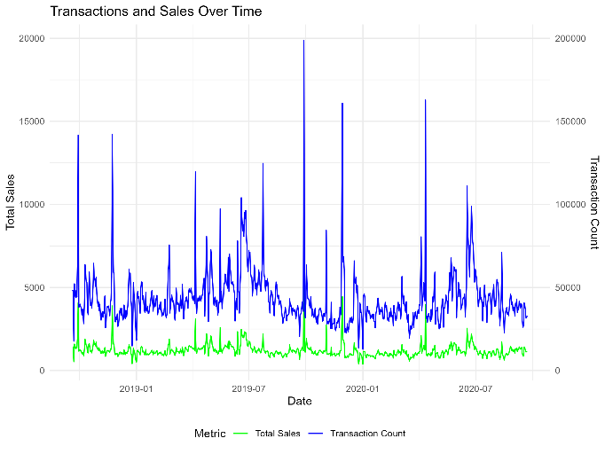
Figure 7: Combined Transactions and Sales Over Time
This plot shows the daily number of transactions and total sales over time for the ‘Garment Upper body’ product group. The blue line represents the number of transactions on a daily basis, while the green line represents the total sales on a daily basis from January 2019 to August 2020.

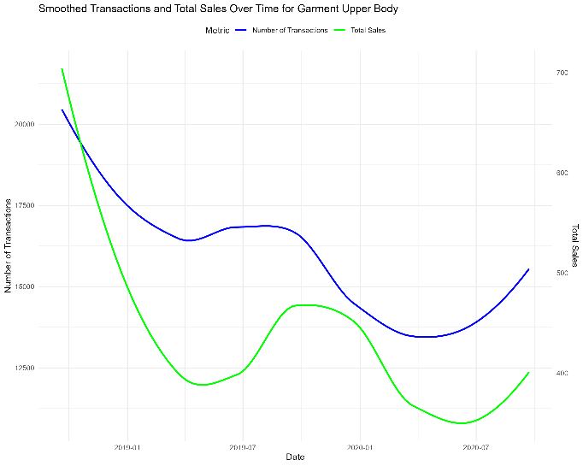
Figure 8: Smoothed Transactions and Sales Over Time
This plot shows the smoothed trend of the number of transactions and total sales over time from Figure 7. The number of transactions and total sales both show a decreasing trend initially, reaching a low point around mid-2019. After mid-2019, both the number of transactions and total sales show a gradual increase, with some fluctuations. The smoothing helps in identifying the overall trend without the noise of daily variations.

Both Figure 7 and 8 provide insights into the seasonal trends and overall patterns in the sales and transactions for this product group, helping to understand customer behavior and sales performance over time.

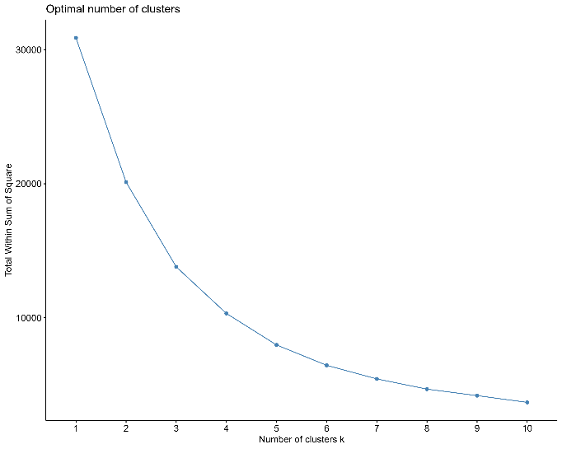
Figure 9: Elbow Plot
The elbow plot is used to determine the optimal number of clusters (k) by plotting the total within-cluster sum of squares (WSS) against the number of clusters. The WSS measures the variance within each cluster, and a lower WSS indicates that data points are closer to their respective centroids. The x-axis represents the number of clusters tested, starting from one up to a specified maximum; in the case of Figure 9, there are ten. The y-axis represents the total WSS for each number of clusters. The WSS generally decreases as the number of clusters increases, because more clusters mean that the data points are closer to the centroids.

The elbow point is where the rate of decrease sharply slows down. Before this point, adding more clusters significantly reduces WSS, but after this point, the reduction in WSS diminishes. In Figure 9, the elbow is around four clusters, which suggests that using four clusters might provide a good balance between having enough clusters to reduce WSS and not having too many clusters, which could lead to overfitting.

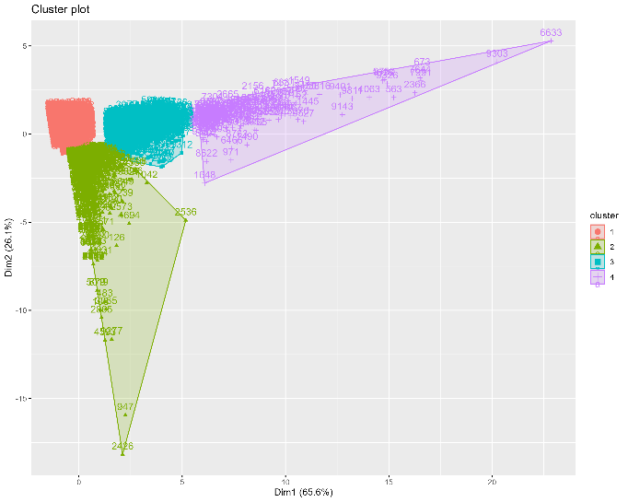
Figure 10: K-means Cluster Plot
The K-means clustering plot is a visual representation of how the customers have been grouped into four distinct clusters based on their purchasing behavior, such as total purchases, total spending, and average spending. The axes labeled ‘Dim1’ and ‘Dim2’ represent the first two principal components (dimensions) that capture the most variance in the data. These dimensions are linear combinations of the original variables and allow us to project the data into a 2D space for visualization purposes. ‘Dim1’ explains 65.6% of the variance, and ‘Dim2’ explains 28.1%, meaning these two dimensions together account for 93.7% of the variability in the data.

The plot shows four clusters, each represented by a different color and shape, while each point in the plot corresponds to a customer, and customers within the same cluster are more similar to each other in terms of their purchasing behavior. The shaded areas around each cluster represent the boundaries of the clusters and show where most of the customers in each cluster are located. The convex hull (the smallest polygon that can enclose all the points in a cluster) is used to draw these boundaries.

The clusters are numbered from 1-4, with the corresponding color and shape provided in the legend on the right. This numbering is arbitrary and does not imply any ranking or order among the clusters.

Each cluster represents a group of customers with similar purchasing patterns; clusters that are more spread out may have more diverse behaviors among their customers, while tighter clusters indicate more similarity within the group:

- Cluster 1 (green): customers in this cluster might have higher total spending, with lower average spending per purchase.
- Cluster 2 (red): these customers might have lower total purchases but higher than average spending.
- Cluster 3 (teal): this cluster could represent customers who are more moderate in both total purchase as well as spending.
- Cluster 4 (purple): customers in this cluster might have high total purchases, with a broader range in spending.

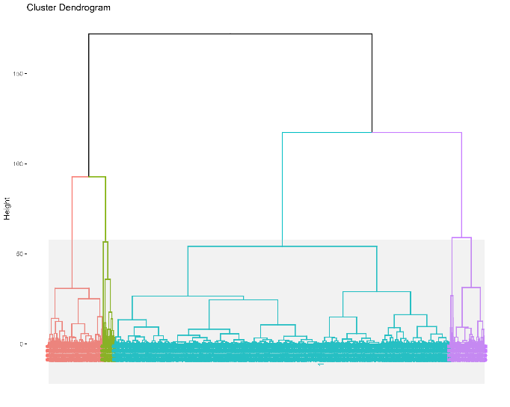
Figure 11: Dendrogram (agglomerative clustering)
The dendrogram is a visual representation of the hierarchical clustering process, showing how individual data points or clusters are progressively merged into larger clusters. It is a tree-like diagram where each leaf represents a data point, and each node (where branches meet) represents a merger of two clusters. As part of the exploratory analysis, the dendrogram in Figure 11 has been cut to a height of 50 to reduce computational complexity, and can inform future decisions on cluster formation, making it a critical tool for determining the optimal number of clusters in subsequent analysis.

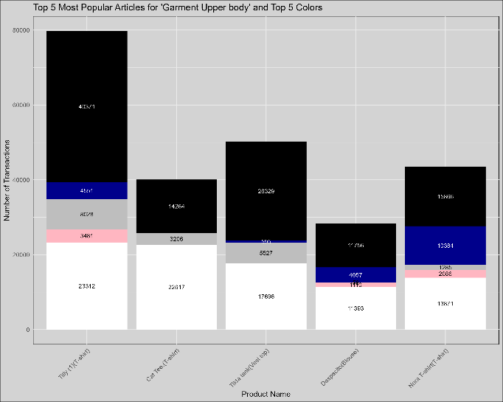
Figure 12: Top 5 Most Popular Products Purchased
It is clear that black and white are the most favored colors, which guided our regression analysis, as well as our recommendations.

Regression Analysis
We chose linear regression as it is simple and widely understood. One of the most basic forms of predictive modeling, linear regression provides predictors (independent variables) and target (dependent variable) that are easy to interpret. Linear regression is also computationally efficient, especially with large datasets, and it often performs well as a predictive model when the relationships in the data are straightforward and linear.

The following plots illustrate the performance of the predictive model for each of the top five products (see Figure 12). The top plot displays the actual versus predicted purchase counts for the color black, while the bottom plot presents the same comparison for the color white. These plots allow us to assess how well the linear regression model captured the relationship between the purchase counts and time-related variables.

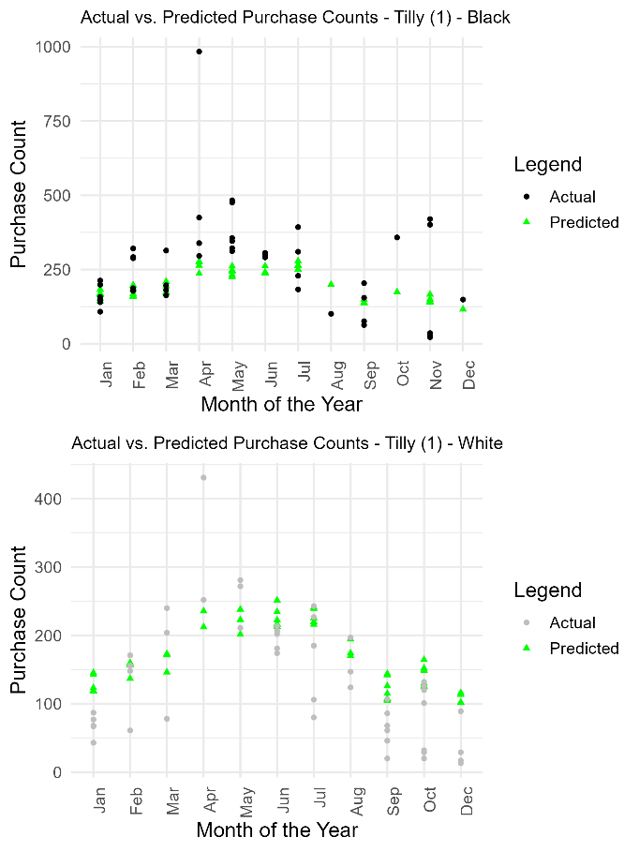
Figure 13: Tilly (T-shirt)
The predicted values closely align with the actual purchase counts for the Tilly, especially during peak months. This suggests that the model performs well for this product in black.

The model also shows a similar trend for the white color, although there might be some deviations during certain months, which could indicate potential areas for model improvement.

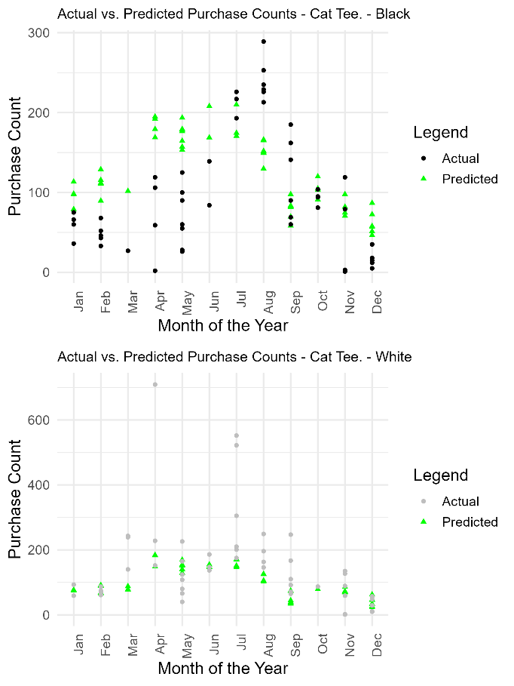
Figure 14: Cat Tee (T-shirt)
The model predictions for the black variant of the Cat Tee show a consistent trend with actual purchases, particularly during mid-year months. Any significant outliers could be identified as unusual purchasing behavior.

For the white variant, while the overall trend matches, certain months where the model over- or under-predicts could indicate possible factors not accounted for by the model.

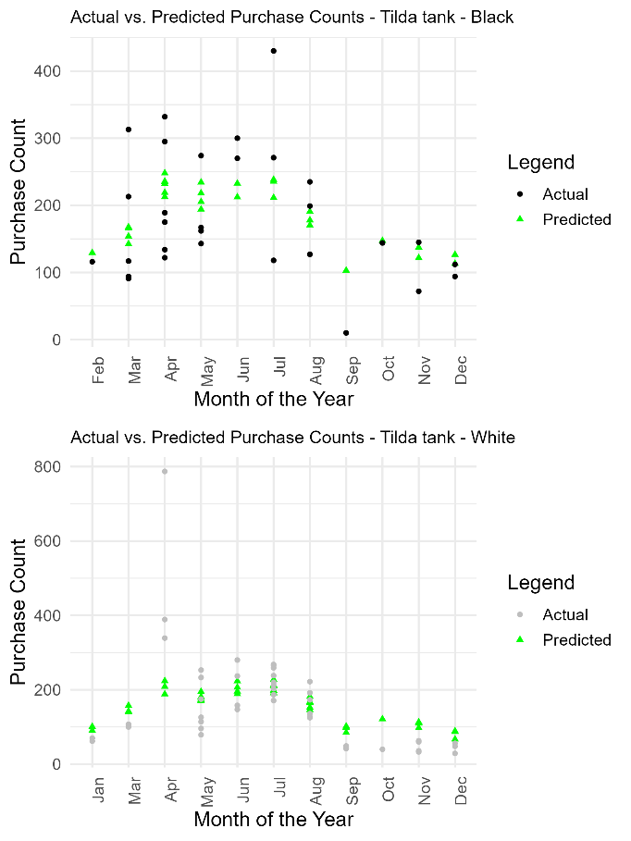
Figure 15: Tilda tank (Vest top)
The predictions for the Tilda tank black variant demonstrate that the model captures the general seasonal trend, though there might be periods of over-prediction, especially during later months. It is important to note that there were no sales of the black variant in January.

The white variant’s predictions follow the actual data closely in the earlier months, but deviations in later months may point to external influences not captured in the dataset.

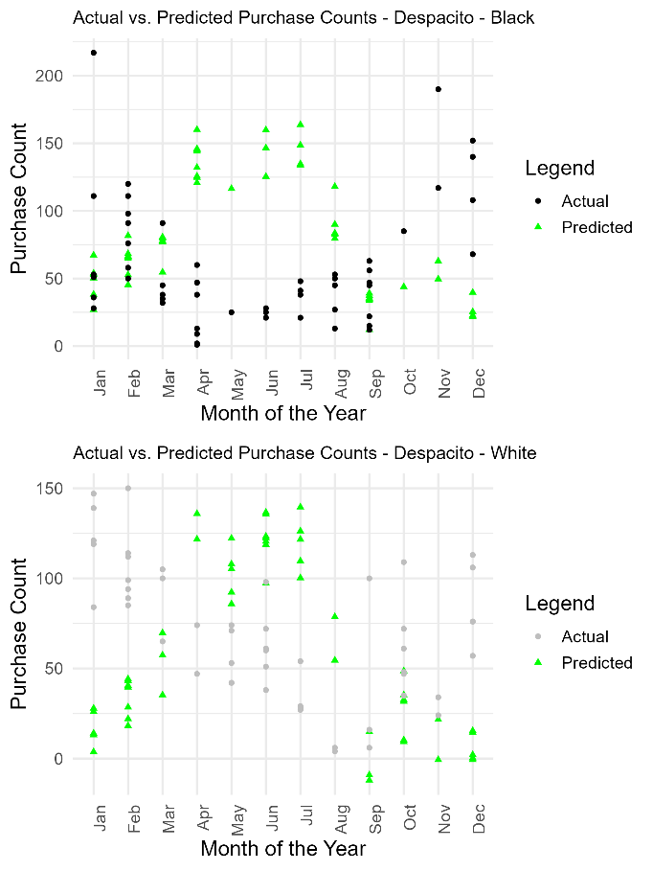
Figure 16: Despacito (Blouse)
The model performs reasonably well for the black variant of the Despacito, capturing the main trends in the data. Any months with larger errors might suggest sudden shifts in consumer preferences or stock issues.

The white variant shows a similar pattern, although discrepancies might suggest either market trends that the model did not account for or data limitations.

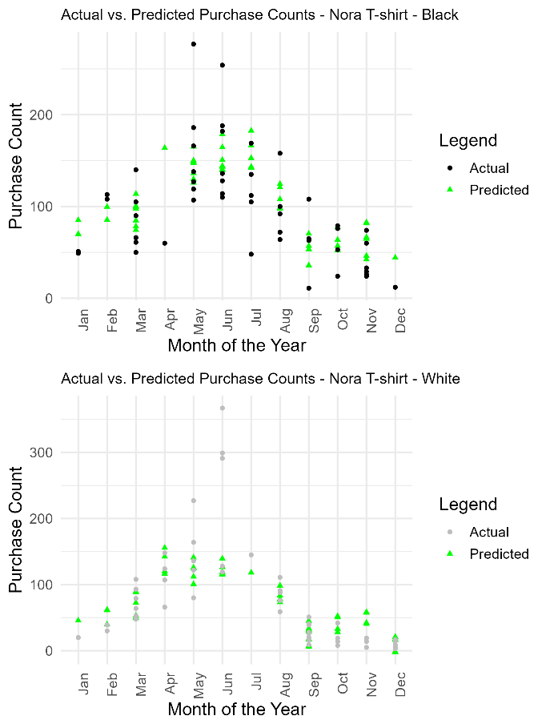
Figure 17: Nora (T-shirt)
For the Nora, the black variant’s plot shows that the model generally follows actual purchase patterns but highlights a few periods where the predictions deviate more significantly, suggesting the need for further refinement in those areas.

The white variant’s accuracy is relatively consistent, but small deviations still exist, especially during certain peak seasons, which could be explored further for model enhancement.

5. RECOMMENDATIONS

Focusing on the ‘Garment Upper body’ product group, we identified the top five most popular products sold, along with the top five most popular colors for each product.

Leverage Customer Segmentation for Personalized Recommendations
Using K-means clustering, the customer base was segmented into four distinct groups based on purchasing behavior. Each cluster offers unique insights for personalizing recommendations:
- Cluster 1 (High total spending, lower average spending per purchase): Target these customers with recommendations for affordable items to drive frequent purchases. This group would also benefit from loyalty programs that encourage repeat shopping through frequency-based rewards.
- Cluster 2 (Low total purchases, higher average spending per purchase): These customers are quality-driven and can be targeted with premium and sustainable products, such as H&M’s Conscious Collection, which emphasizes eco-friendly options.
- Cluster 3 (Moderate purchases and spending): Recommendations should focus on complementary items like accessories and shoes, as well as newly arrived or seasonal products that align with their moderate spending behavior.
- Cluster 4 (High total purchases with diverse spending behavior): These customers exhibit varying spending behaviors. Utilizing hierarchical clustering (as demonstrated in Figure 11) can further segment this group to provide hyper-targeted recommendations based on their specific preferences.

Product Attributes to Refine Recommendations
The analysis of product attributes such as color and style highlighted that certain preferences, particularly for black, white, and blue products, dominate across the customer base. These preferences can be leveraged for:
- Personalized product suggestions that align with individual customer preferences.
- Cross-selling opportunities where product recommendations are matched based on color, allowing customers to complete outfits.
For example, customers in Cluster 1 demonstrate a strong preference for these colors, allowing H&M to refine recommendations based on dominant color trends.

Addressing the Cold Start Problem with Demographic and Product Attributes
Demographics and product attributes from new customers in different regions can help tackle the cold start problem, where there is insufficient data to recommend products. H&M’s vast online presence in over 60 countries allows the recommendation system to:
- Use market-specific trends and bestsellers from a customer's region as initial recommendations.
- Match new customers with popular product categories and color preferences from similar segments.
This approach ensures new customers receive relevant and appealing recommendations even without extensive shopping history.

Enhancing Supply Chain Efficiency through Recommender Systems
Currently, H&M's online sales constitute 30% of the total sales for the group, which emphasizes the growing importance of digital platforms in driving overall revenue (H&M Group, 2023 p. 11). Implementing a recommender system can significantly improve H&M’s supply chain operations by predicting customer demand, particularly in relation to seasonal trends, which would have a direct impact on inventory management and supply chain optimization.

Predicting Seasonal Trends:
The recommendation system can analyze purchasing behavior across customer segments and use that data to forecast demand spikes for specific products, especially during key seasons such as the holiday season, back-to-school, or summer. With better insights into future trends, H&M can adjust inventory levels proactively, ensuring popular items are in stock while minimizing excess inventory of less popular items.

Real-Time Supply Chain Adjustments:
The recommendation system can also aid in real-time adjustments in the supply chain. By integrating real-time purchasing data with warehouse and logistics operations, H&M can optimize order fulfillment processes. For example, the system could automatically adjust orders from suppliers based on real-time customer purchases and trends, ensuring that the supply chain is responsive and agile, reducing the risk of delays or over-ordering.

Sustainability and Waste Reduction:
In addition to optimizing stock levels, a recommender system can support H&M’s sustainability goals by minimizing waste. By better predicting customer preferences and trends, the company can reduce the production of items that are less likely to sell, cutting down on excess inventory and reducing the need for markdowns or disposal of unsold items. This contributes to a more efficient and environmentally friendly supply chain, aligning with H&M's emphasis on sustainable practices.

6. LITERATURE REVIEW

The evolution of recommender systems from simple collaborative filtering models to sophisticated hybrid approaches has been driven by the need to overcome inherent challenges like the cold start and sparsity problems. Early recommendation systems focused on alleviating information overload by providing customers with personalized suggestions based on their past behaviors (Martin et al., 2011). However, these systems often prioritized business interests, such as maximizing short-term sales, at the expense of enhancing the customer experience. As the field has advanced, there has been a notable shift toward more customer-centered approaches that not only recommend what is likely to be purchased next but also consider the customer’s broader context, long-term goals, and preferences (Ricci, Rokach, & Shapira, 2015).

Addressing the Cold Start and Sparsity Problems
Two of the most persistent challenges in recommendation systems are the cold start and sparsity problems. The cold start problem arises when there is insufficient data on new customers or items, making it difficult for the system to generate accurate recommendations. Hybrid recommendation systems, which combine collaborative filtering with content-based approaches, are particularly effective in mitigating this issue. By leveraging demographic data or content attributes, these systems can generate meaningful recommendations even with limited initial information (Ricci et al., 2015). Similarly, the sparsity problem, which occurs due to the lack of sufficient customer-item interactions, is addressed through advanced data mining techniques like matrix factorization and clustering. These methods uncover latent patterns within sparse datasets, enhancing the system’s ability to deliver accurate recommendations despite limited data (Koren, Bell, & Volinsky, 2009).

Data Mining in Recommender Systems
Data mining plays a crucial role in enhancing the performance of hybrid recommender systems. Techniques such as clustering, association rule mining, and dimensionality reduction are central to extracting meaningful insights from large datasets. For instance, K-means clustering is widely used to segment customers based on their purchasing behavior, allowing for the creation of more targeted and relevant recommendations. Similarly, hierarchical clustering provides a more nuanced understanding of customer groups, enabling the system to identify sub-clusters that reveal specific preferences (Ricci et al., 2015). These data mining methods are integral to overcoming the challenges posed by sparse and incomplete data, ultimately leading to more personalized and accurate recommendations (Ricci et al., 2015).

Types of Data Used in Recommender Systems
The effectiveness of a recommendation system is heavily influenced by the types of data it processes. Customer ratings, clickstream data, and item attributes are all crucial for generating accurate predictions. Hybrid models excel by integrating multiple data sources, combining customer interaction data with content-based information to offer a multi-faceted approach to personalization. This integration not only enhances the system’s ability to make relevant recommendations but also helps to mitigate issues like the cold start and sparsity problems (Burke, 2002).

Applications in E-commerce
The application of recommender systems in e-commerce has been transformative, significantly enhancing customer experience and driving sales. Platforms like Amazon and Netflix have demonstrated the power of hybrid recommendation systems in creating personalized shopping experiences that align with individual customer preferences. By analyzing customer behavior and segmenting customers into distinct profiles, these systems can deliver highly relevant product recommendations that resonate with each customer’s unique needs (Schafer, Konstan, & Riedl, 2001). The integration of data mining techniques further refines these recommendations, ensuring that they are both timely and contextually appropriate, thereby increasing customer engagement and loyalty (Ricci et al., 2015).

The continued evolution of recommendation systems highlights the importance of balancing business objectives with the need to deliver recommendations that genuinely resonate with customers. By addressing challenges such as the cold start and sparsity problems, leveraging data mining techniques, and integrating diverse data types, hybrid models represent the next generation of recommender systems. These systems not only enhance the accuracy of recommendations but also provide a more personalized and satisfying customer experience, particularly in the context of e-commerce. As the field advances, the focus on customer-centered design and the integration of emerging technologies like deep learning and real-time data processing will likely drive further innovation in this critical area of research (Adomavicius & Tuzhilin, 2005; Zhang, Yao, Sun, & Tay, 2019).

7. LIMITATIONS

The results of this study are subject to certain limitations inherent to the clothing industry. The industry is characterized by its highly unpredictable and rapidly changing nature, which can significantly impact consumer behavior and purchasing patterns. Fashion trends, by their very nature, are often short-lived, meaning that what is popular today may quickly become outdated. This volatility introduces a level of uncertainty into our analysis, potentially skewing the results.

For instance, the preference for specific garments or styles can shift dramatically within a short time frame, leading to fluctuations in sales data that may not accurately reflect long-term consumer behavior. Additionally, external factors such as seasonal changes, marketing campaigns, and cultural influences further contribute to the unpredictability of fashion trends, complicating efforts to derive consistent insights.

As a result, while the findings of this study provide valuable insights into current patterns, they should be interpreted with caution, considering the transient nature of fashion trends and the broader context of the ever-changing clothing industry.

8. CONCLUSIONS

This project serves as a comprehensive analysis of H&M's customer sales data, aiming to uncover current trends while forecasting future patterns in customer behavior. By leveraging advanced R programming techniques, such as K-means and agglomerative clustering, we successfully segmented customers into distinct groups based on their purchasing behavior. These detailed customer segment profiles not only provide insights into consumer preferences but also form the basis for improving H&M’s recommendation system through collaborative filtering. This approach enhances personalized product recommendations, making it possible to cater more effectively to individual customer needs.

The integration of descriptive and predictive analytics, including regression and time-series analysis, allowed us to identify key opportunities for H&M, such as seasonal trends, customer preferences for specific product groups, and purchasing patterns over time. These insights enable H&M to refine its marketing strategies, optimize inventory management, and align supply chain operations with anticipated demand. For example, by analyzing the color preferences and product groupings, the company can make data-driven decisions about product design, marketing, and inventory allocation, ensuring they meet customer demand while minimizing excess stock.

Visualization tools like ggplot2 played a crucial role in interpreting the findings. Through clear visual representations, we were able to communicate complex data insights in a way that is accessible to various stakeholders, facilitating informed decision-making across departments. From identifying the most popular product colors to analyzing transaction and sales trends over time, these visualizations provided a powerful way to understand customer behavior and trends.

Furthermore, the project addressed critical challenges such as the cold start problem in recommendation systems, which occurs when new customers have little to no purchasing history. By utilizing demographic and product attributes, we ensured that even new customers receive relevant and tailored recommendations, helping H&M maintain strong customer engagement from the first interaction.

In terms of methodology, the project focused heavily on data preprocessing to ensure the integrity and quality of the dataset. This included handling missing values, normalization, and careful consideration of outliers, which were preserved to maintain the integrity of the dataset. This robust approach to data preparation laid a strong foundation for subsequent modeling and analysis.

Lastly, this project’s emphasis on predictive analytics equips H&M with the tools to proactively respond to changing customer preferences and market trends. By predicting seasonal trends and adjusting supply chain operations accordingly, H&M can ensure they have the right inventory at the right time, reducing the risk of stock shortages or overproduction. This not only improves customer satisfaction but also aligns with H&M’s sustainability goals by minimizing waste and optimizing resource usage.

The combination of advanced segmentation techniques, predictive modeling, and data-driven decision-making provides H&M with a competitive edge in the fashion industry. The insights gained from this analysis will help H&M enhance customer experiences, streamline operations, and improve business outcomes in a rapidly evolving market.

9. ACKNOWLEDGEMENTS

The authors wish to acknowledge the support of Dr. Paul Dooley, City University of Seattle, for his invaluable input and guidance. We also express our appreciation to Humaira Akram Khan, Jan McConnell, and Rosalia Miray for their significant contributions as co-authors of this paper.

10. REFERENCES

Adomavicius, G., & Tuzhilin, A. (2005). Toward the next generation of recommender systems: A survey of the state-of-the-art and possible extensions. IEEE Transactions on Knowledge and Data Engineering, 17(6), 734-749. https://ieeexplore.ieee.org/document/1423975/
Burke, R. (2002). Hybrid recommender systems: Survey and experiments. User Modeling and User-Adapted Interaction, 12(4), 331-370. https://doi.org/10.1023/A:1021240730564
EMC Education Services (Eds.). (2015). Data Science and Big Data Analytics: Discovering, Analyzing, Visualizing and Presenting Data. John Wiley & Sons.
H&M Group. (2023). H&M Group Annual and Sustainability Report 2023 (Annual Report). H&M Group. Retrieved from https://hmgroup.com/wp-content/uploads/2024/03/HM-Group-Annual-and-Sustainability-Report-2023.pdf
Harbert, T. (2021, February 1). Tapping the power of unstructured data. MIT Sloan. https://mitsloan.mit.edu/ideas-made-to-matter/tapping-power-unstructured-data
Kaggle. (2024). H&M personalized fashion recommendations. https://www.kaggle.com/competitions/h-and-m-personalized-fashion-recommendations/
Koren, Y., Bell, R., & Volinsky, C. (2009). Matrix factorization techniques for recommender systems. IEEE Computer, 42(8), 30-37. https://doi.org/10.1109/MC.2009.263
Martin, F. J., Donaldson, J., Ashenfelter, A., Torrens, M., & Hangartner, R. (2011). The big promise of recommender systems. AI Magazine, 32(3), 19-27. https://doi.org/10.1609/aimag.v32i3.2360
R Core Team. (n.d.) Manuals. CRAN. https://cran.r-project.org/manuals.html
Ricci, F., Rokach, L., & Shapira, B. (Eds.). (2015). Recommender systems handbook (2nd ed.). Springer. https://doi.org/10.1007/978-1-4899-7637-6
Schafer, J. B., Konstan, J. A., & Riedl, J. (2001). E-commerce recommendation applications. Data Mining and Knowledge Discovery, 5(1-2), 115-153. https://doi.org/10.1023/A:1009804230409
Zhang, S., Yao, L., Sun, A., & Tay, Y. (2019). Deep learning based recommender system: A survey and new perspectives. ACM Computing Surveys, 52(1), 1-38. https://doi.org/10.1145/3285029

11. GLOSSARY

- Agglomerative clustering algorithm – Also known as AGNES (Agglomerative Nesting), is a bottom-up approach that groups objects into clusters based upon their similarity. See also Hierarchical clustering.
- Collaborative filtering – A technique used in recommendation systems that makes predictions about a user’s interests by collecting preferences from many users.
- CRAN – acronym for Comprehensive R Archive Network, which is a host repository for R packages, source code, and documentation; serves as a central hub for the R programmer community.
- Data cleaning – The process of detecting and correcting (or removing) corrupt or inaccurate records from a dataset to improve the quality of the data.
- Data visualization – The graphical representation of information and data using visual elements like charts, graphs, and maps.
- Exploratory Data Analysis (EDA) – An approach to analyzing datasets to summarize their main characteristics, often using visual methods.
- Feature engineering – The process of using domain knowledge to create new features that help machine learning models perform better.
- Hierarchical clustering – A method of cluster analysis which seeks to build a hierarchy of clusters, either by starting with individual points and merging them (agglomerative) or by starting with the entire dataset and splitting it. See also Agglomerative clustering algorithm.
- K-means clustering – An unsupervised machine learning technique that groups unlabeled data into clusters.
- Pattern mining – The process of discovering patterns or regularities in large datasets.
- Precision – A metric used to evaluate the accuracy of a recommendation system, defined as the number of true positive results divided by the number of all positive results, including those not identified correctly.
- Recall – A metric used to evaluate the completeness of a recommendation system, defined as the number of true positive results divided by the number of all relevant samples (all samples that should have been identified as positive).
- Segmentation – The process of dividing a dataset into distinct groups that share similar characteristics.
- Supervised learning – A type of machine learning where the model is trained on labeled data, meaning that each training example is paired with an output label.
- Support – In association rule mining, the support of an itemset is the proportion of transactions in the dataset in which the itemset appears.
- Unsupervised learning – A type of machine learning where the model is trained on unlabeled data and must find hidden patterns or intrinsic structures in the input data.
- Within Sum of Squares – Measures the compactness of the clustering by calculating the distance of each item its relative centroid.

